**4**

**Motion in Two Dimensions**

|  |
| --- |
| **CHAPTER OUTLINE** |

4.1 The Position, Velocity, and Acceleration Vectors

4.2 Two-Dimensional Motion with Constant Acceleration

4.3 Projectile Motion

4.4 Analysis Model: Particle in Uniform Circular Motion

4.5 Tangential and Radial Acceleration

4.6 Relative Velocity and Relative Acceleration

\* An asterisk indicates an item new to this edition.

|  |
| --- |
| **SOLUTIONS TO THINK-PAIR-SHARE AND ACTIVITIES** |

**\*TP4.1 Conceptualize** The diagram below (see Fig. ANS TP4.1) shows a closeup of the stairs, with the appropriate length values indicated. Imagine the marble rolling horizontally toward the right off the upper landing and flying into the air. If it is rolling slowly, it will fall off the upper landing and strike the first step. We want its trajectory to be such that it misses that step, which will require a certain minimum rolling speed.

**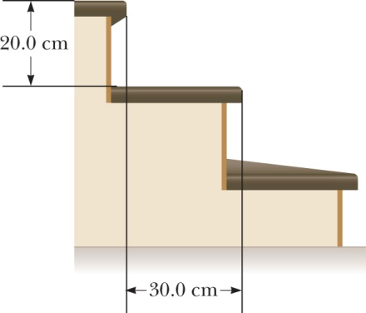**

**Categorize** This is a projectile problem, so we use the *particle under constant acceleration* model for the vertical motion of the ball and the *particle under constant velocity* model for its horizontal motion.

**Analyze** Let the marble leave the upper landing at time *t* = 0. At time *t*, the marble has position coordinates *xf* and *yf*. Therefore, from the *particle under constant acceleration* and *particle under constant velocity* models, substituting values for the initial coordinates and initial vertical velocity component,



Solve Equation (1) for the time *t* and substitute into Equation (2) to find the horizontal projection velocity:



(a) To find the minimum speed for the marble to miss the first step, evaluate the equation for the horizontal projection velocity using the coordinates of the edge of that step:



(b) To find the minimum speed for the marble to miss the second step, evaluate the equation for the horizontal projection velocity using the coordinates of the edge of that step:



(c) To find the minimum speed for the marble to miss *all* the steps, evaluate the equation for the horizontal projection velocity using the coordinates of the edge of the *eleventh* step:



This is not a particularly high speed, so it should be possible for your toddler nephew to propel the marble with this speed.

(d) We can calculate the required speed for the marble to land on the sixth step as we have above for other steps. If the marble were projected *horizontally* from the sixth step at this same speed, it would clear the remaining six steps. When it bounces off the sixth step, however, it has this horizontal component of velocity *along with* an upward vertical component that will keep it in the air even longer and allow its horizontal displacement to increase more than it did for the flight from the upper landing. Therefore, the marble should hit the floor of the lower landing beyond the lowest step.

**Finalize** Is it clear why we substituted 11 in part (c) rather than 12? Notice that the required projection speed does not increase linearly with the number of steps. From part (a) to part (c), it requires a little over *three* times as much speed to miss *eleven* times as many steps. Is that consistent with your conception of projectile motion?

*Answers:* (a) 1.48 m/s (b) 2.10 m/s (c) yes, at 4.92 m/s (d) The last step, the twelfth, is down to the landing. The speed of projection allows the ball to reach the sixth step and then another six steps to the landing, even without including its vertical motion after bouncing from the sixth step. Including the vertical motion for the bounce, the ball is in the air after the sixth step for an even longer time, causing the ball to make its second bounce well beyond the last step.

**\*TP4.2** The time interval should be zero, because the vertical falling motion is unaffected by the horizontal motion of the pennies. In the absence of an audio recording, students can just listen for the sound of the pennies hitting the floor. They should not hear two distinct sounds.

*Answer:* The time interval should be zero, because the vertical falling motion is unaffected by the horizontal motion of the pennies.

|  |
| --- |
| **SOLUTIONS TO END-OF-CHAPTER PROBLEMS** |

Section 4.1 The Position, Velocity, and Acceleration Vectors

**P4.1**  (a) For the average velocity, we have





(b) For the velocity components, we have



and 

Therefore,





and the speed is



**P4.2** (a) From  we determine the components of the velocity by taking the time derivatives of *x* and *y*:



and 

At *t* = 0,



(b) Acceleration is the time derivative of the velocity, so



and 

At t = 0,



(c) 





(d) 

Section 4.2 Two-Dimensional Motion with Constant Acceleration

**P4.3** (a) We differentiate the equation for the vector position of the particle with respect to time to obtain its velocity:



(b) Differentiating the expression for velocity with respect to time gives the particle’s acceleration:



(c) By substitution, when t = 1.00 s,



**P4.4** (a) For the *x* component of the motion we have 





We choose the + sign to represent the physical situation:



Here



So, 

(b) 

(c) 

(d) 

**P4.5** The directions of the position, velocity, and acceleration vectors are given with respect to the x axis, and we know that the components of a vector with magnitude *A* and direction *θ* are given by *A*x = *A* cos*θ* and *A*y = *A* sin*θ* ; thus we have







where  is in m,  in m/s,  in m/s2, and t in s.

(a) From 



where  in m/s and t in s.

(b) The car’s position vector is given by





where  is in m and t in s.

Section 4.3 Projectile Motion

**P4.6** The mug is a projectile from just after leaving the counter until just before it reaches the floor. Taking the origin at the point where the mug leaves the bar, the coordinates of the mug at any time t are



and



(a) When the mug reaches the floor, yf = h and xf = d, so



is the time of impact, and





(b) Just before impact, the x component of velocity is still

*vxf* = *vxi*

while the *y* component is



Then the direction of motion just before impact is below the horizontal at an angle of





because the x component of velocity is positive (forward) and the y component is negative (downward).



**P4.7** At the maximum height  and the time to reach this height is found from

 as .

The vertical displacement that has occurred during this time is



Thus, if  then



and if the angle of projection is , the launch speed is



**P4.8** We ignore the trivial case where the angle of projection equals zero degrees.



so 

or 

thus, 

**P4.9** Consider the motion from original zero height to maximum height *h:*

 gives 

or 

Now consider the motion from the original point to half the maximum height:

 gives 

so 

At maximum height, the speed is 

Solving,



Now the projection angle is



**P4.10** (a) We ignore the trivial case where the angle of projection equals zero degrees. Because the projectile motion takes place over level ground, we can use Equations 4.12 and 4.13:



Expanding,



(b) The maximum range is attained for *θ*i = 45°:



then



(c) 

**P4.11** The horizontal component of displacement is xf = vxit = (vi cos*θ*i)t. Therefore, the time required to reach the building a distance *d* away is . At this time, the altitude of the water is



Therefore, the water strikes the building at a height *h* above ground level of



**P4.12** From the instant he leaves the floor until just before he lands, the basketball star is a projectile. His vertical velocity and vertical displacement are related by the equation  Applying this to the upward part of his flight gives  From this, *vyi* = 4.03 m/s. [Note that this is the answer to part (c) of this problem.]

For the downward part of the flight, the equation gives  Thus, the vertical velocity just before he lands is *vyf* = –4.32 m/s.

(a) His hang time may then be found from vyf = vyi + ayt:

–4.32 m/s = 4.03 m/s + (–9.80 m/s2)t

or 

(b) Looking at the total horizontal displacement during the leap, x = vxit becomes

2.80 m = vxi (0.852 s)

which yields 

(c)  See above for proof.

(d) The takeoff angle is: 

(e) Similarly for the deer, the upward part of the flight gives





so vyi = 5.04 m/s

For the downward part,  yields



The hang time is then found as 

 and



**P4.13** (a) Initial coordinates: 

(b) Components of initial velocity: 

(c) 

(d)  There is no horizontal acceleration from gravity.

(e) 



(f) 



(g) We find the time of impact:



(h) At impact, vxf = vxi = 18.0 m/s, and the vertical component is



Thus,



and



which in this case means the velocity points into the fourth quadrant because its *y* component is negative.

**P4.14** (a) When a projectile is launched with speed vi at angle *θ*i above the horizontal, the initial velocity components are vxi = vi cos *θi* and vyi = v*i* sin *θ*i. Neglecting air resistance, the vertical velocity when the projectile returns to the level from which it was launched (in this case, the ground) will be vy = –vyi. From this information, the total time of flight is found from vyf = vyi + ayt to be



Since the horizontal velocity of a projectile with no air resistance is constant, the horizontal distance it will travel in this time (i.e., its range) is given by



Thus, if the projectile is to have a range of R = 81.1 m when launched at an angle of *θi* = 45.0°, the required initial speed is



(b) With v*i* = 28.2 m/s and *θi* = 45.0° the total time of flight (as found above) will be



(c) Note that at *θi* = 45.0°, and that sin (2*θi*) will decrease as *θi* is increased above this optimum launch angle. Thus, if the range is to be kept constant while the launch angle is increased above 45.0°, we see from  that 

Observe that for *θi* < 90°, the function sin*θi* increases as *θi*is increased. Thus, increasing the launch angle above 45.0° while keeping the range constant means that both v*i* and sin*θi* will increase. Considering the expression for ttotal given above, we see that 

**P4.15** (a) The time for the ball to reach the fence is



At this time, the ball must be  above its launch position, so



gives



or



from which we obtain



(b) From our equation for the time of flight above,



(c) When the ball reaches the wall (at *t* = 3.81 s),



and 

**P4.16** The initial velocity components of the projectile are

xi = 0 and yi = h

vxi = vi cos*θ* and vyi = vi sin*θ*

while the constant acceleration components are

ax = 0 and ay = –g

The coordinates of the projectile are



and the components of velocity are



(a) We know that when the projectile reaches its maximum height,   
vyf = 0:



(b) At the maximum height, y = hmax:

****

**P4.17** We first consider the vertical motion of the stone as it falls toward the water. The initial *y* velocity component of the stone is



and its *y* coordinate is



where *y* is in m and *t* in s. We have taken the water’s surface to be at   
y = 0. At the water,

4.90*t*2 + 3.46*t* – 2.50 = 0

Solving for the positive root of the equation, we get



The *y* component of velocity of the stone when it reaches the water at this time t is



After the stone enters to water, its speed, and therefore the magnitude of each velocity component, is reduced by one-half. Thus, the y component of the velocity of the stone in the water is



and this component remains constant until the stone reaches the bottom. As the stone moves through the water, its *y* coordinate is



The stone reaches the bottom of the pool when yf = –3.00 m:



The total time interval the stone takes to reach the bottom of the pool is



Section 4.4 Analysis Model: Particle in Uniform Circular Motion

**P4.18** Centripetal acceleration is given by  To find the velocity of a point at the equator, we note that this point travels through  (where  is Earth’s radius) in 24.0 hours. Then,



and,



**P4.19** The satellite is in free fall. Its acceleration is due to gravity and is by effect a centripetal acceleration: *ac* = *g*. So



Solving for the velocity,





and



**P4.20** (a) Using the definition of speed and noting that the ball travels in a circular path,



where *R* is the radius of the circle and *T* is the period, that is, the time interval required for the ball to go around once. For the periods given in the problem,



Therefore, the speeds in the two cases are:



Therefore,  gives the greater speed of the ball.

(b) 

(c) At 6.00 rev/s, acceleration  So 8 rev/s gives the higher acceleration.

**P4.21** Model the discus as a particle in uniform circular motion. We evaluate its centripetal acceleration from the standard equation proved in the text.



The mass is unnecessary information.

**P4.22** The radius of the tire is *r* = 0.500 m. The speed of the stone on its outer edge is

****

and its acceleration is



Section 4.5 Tangential and Radial Acceleration

**P4.23** The particle’s centripetal acceleration is v2/r = (3 m/s)2/2 m =   
4.50 m/s2. The total acceleration magnitude can be larger than or equal to this, but not smaller.

(a) 

(b) 

**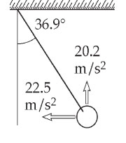P4.24** (a) See ANS. FIG. P4.24.

(b) The components of the 20.2 m/s2 and the   
22.5 m/s2 accelerations along the rope together   
constitute the centripetal acceleration:

**ANS. Fig. P4.24**



 (c)  tangent to the circle.

Section 4.6 Relative Velocity and Relative Acceleration

**P4.25**(a) To an observer at rest in the train car, the bolt accelerates downward and toward the rear of the train.



To this observer, the bolt moves as if it were in a gravitational field of 9.80 m/s2 down + 2.50 m/s2 south.

(b) 

(c) 

(d) 

**P4.26**  The westward speed of the airplane is the horizontal component of its velocity vector, and the northward speed of the wind is the vertical component of its velocity vector, which has magnitude and direction given by





**\*P4.27 Conceptualize** If the pilot maintains the centerline of the aircraft parallel to the runway, the crosswind will blow the plane sideways. Therefore, the thrust of the engines of the airplane must be at an angle so that the vector sum of the aircraft speed and the wind speed is a velocity parallel to the runway.

**Categorize** This is a relative velocity problem, involving a vector sum of velocities.

**Analyze** Set up a diagram showing the velocity vectors to be added:

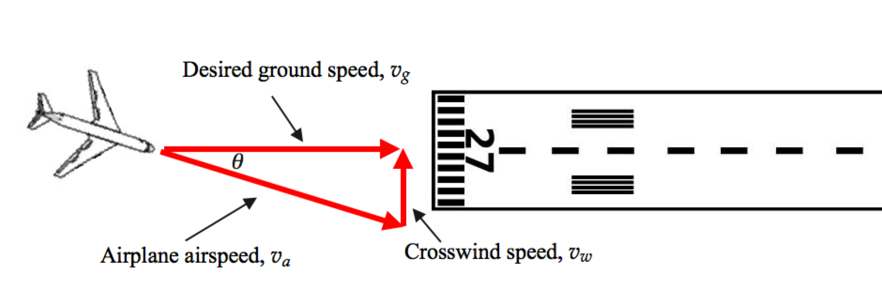

The three vectors shown make up a right triangle. From the definition of the sine of the angle **,

 (1)

Substitute numerical values:



**Finalize** We can find the magnitude of the desired ground speed from the Pythagorean theorem:



It is interesting to look on YouTube for videos of a landing B-52 in a

crosswind. This airplane has a rotating landing gear, so that the wheels

can be parallel to the runway even though the body of the aircraft is at

an angle to the runway. Large commercial airliners often land in

significant crosswind conditions. The challenge for these pilots is to

correct the orientation of the aircraft as soon as the wheels touch down,

as commercial airliners don’t have rotating wheels.

*Answer:* 18.2°

**P4.28** We define the following velocity vectors:

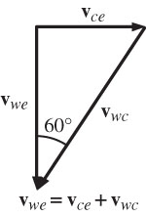  = the velocity of the car relative   
to the Earth

 = the velocity of the water relative   
to the car

**ANS. FIG. P4.28**

 = the velocity of the water relative   
to the Earth

These velocities are related as shown in ANS. FIG. P4.28

(a) Since  is vertical, *vwc* sin 60.0° = vce = 50.0 km/h or



(b) Since  has zero vertical component,



**P4.29** Identify the student as the S′ observer and the professor as the S observer. For the initial motion in S′, we have

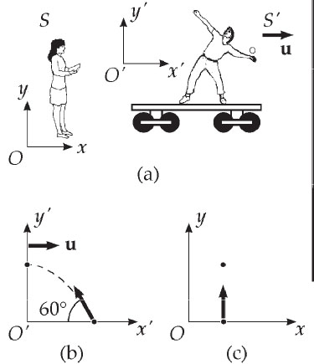 

Let u represent the speed of S′ relative to S. Then because there is no x motion in S, we can write   
vx = v′x + u = 0 so that   
v′x = –u = –10.0 m/s. Hence the ball is thrown backwards in S′. Then,



**ANS. Fig. P4.29**

Using  we find



The motion of the ball as seen by the student in *S*′ is shown in ANS. FIG. P4.29(b). The view of the professor in S is shown in ANS. FIG. P4.29(c).

**P4.30** The total time interval in the river is the longer time spent swimming upstream (against the current) plus the shorter time swimming downstream (with the current). For each part, we will use the basic equation *t* = *d*/*v*, where *v* is the speed of the student relative to the shore.

(a) Total time = time upstream plus time downstream:



Therefore, 

(b) Total time in still water 

(c) 

**P4.31** The student must swim faster than the current to travel upstream.

(a) The speed of the student relative to shore is vup = *c* – v while swimming upstream (against the current), and vdown = *c* + v while swimming downstream (with the current).

Note, The student must swim faster than the current to travel upstream. The time interval required to travel distance d upstream is then



and the time interval required to swim the same distance d downstream is



The time interval for the round trip is therefore



(b) In still water, v = 0, so vup = vdown = c; the equation for the time interval for the complete trip reduces to



**\*P4.32** Choose the x axis along the 20-km distance. The y components of the displacements of the ship and the speedboat must agree:



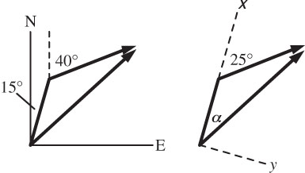 

**ANs. Fig. P4.32**

The speedboat should head



(c) The equation for the time interval for the complete trip can be written as



Because the denominator is always smaller than c, swimming with and against the current is always longer than in still water.

Additional Problems

**P4.33** (a) For the boy to catch the can at the same location on the truck bed, he must throw it 

(b) We find the time of flight of the can by considering its horizontal motion:

16.0 m = (9.50 m/s)*t* + 0 → t = 1.68 s

For the free fall of the can, 



which gives 

(c) The boy sees the can always over his head, traveling in 

(d) The ground observer sees the can move as a projectile traveling in 

(e) Its initial velocity is



at an angle of



**P4.34** After the string breaks the ball is a projectile, and reaches the ground at time *t*:





so *t* = 0.495 s. Its constant horizontal speed is



so before the string breaks



**P4.35** We choose positive *y* to be in the downward direction. The ball when released has velocity components vxi = v and vyi = 0, where v is the speed of the man. We can find the length of the time interval the ball takes to fall the distance h using



The horizontal displacement of the ball during this time interval is



Solve for the speed:



where h is in m and v in m/s.

If we express the height as a function of speed, we have



where h is in m and v is in m/s.



**P4.36** (a) From 



Then



so 

(b) From 



Then



**P4.37** Both Lisa and Jill start from rest. Their accelerations are





Integrating these, and knowing that they start from rest, we find their velocities:





Integrating again, and knowing that they start from the origin, we find their positions:





All of the above are with respect to the ground (G).

(a) In general, Lisa’s velocity with respect to Jill is



When  so the speed (magnitude) is



(b) In general, Lisa’s position with respect to Jill is



When  and their distance apart is



(c) In general, Lisa’s acceleration with respect to Jill is



**P4.38** (a) The stone’s initial velocity components (at t = 0) are vxi and vyi = 0, and the stone falls through a vertical displacement ∆y = –h. We find the time t when the stone strikes the ground using



(b) To find the stone’s initial horizontal component of velocity, we know at the above time t, the stone’s horizontal displacement is ∆x = d:



(c) The vertical component of velocity at time t is



and the horizontal component does not change; therefore, the speed of the stone as it reaches the ocean is



(d) From above,



which means the velocity points below the horizontal by angle



**P4.39** Given the initial velocity, we can calculate the height change of the ball as it moves 130 m horizontally. So this is what we do, expecting the answer to be inconsistent with grazing the top of the bleachers. We assume the ball field is horizontal. We think of the ball as a particle in free fall (moving with constant acceleration) between the point just after it leaves the bat until it crosses above the cheap seats.

The initial components of velocity are



We find the time when the ball has traveled through a horizontal displacement of 130 m:





Now we find the vertical position of the ball at this time:





**P4.40** At any time t, the two drops have identical y coordinates. The distance between the two drops is then just twice the magnitude of the horizontal displacement either drop has undergone. Therefore,



**P4.41** (a) The Moon’s gravitational acceleration is the probe’s centripetal acceleration: (For the Moon’s radius, see end papers of text.)



(b) The time interval can be found from



**P4.42** (a) The length of the cord is given as *r* = 1.00 m. At the positions with 



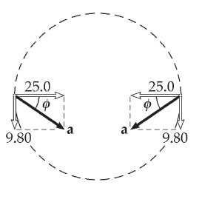 (b) The tangential acceleration is only the acceleration due to gravity, 

**ANs. Fig. P4.42**

(c) See ANS. FIG. P4.42.

(d) The magnitude and direction of the total acceleration at these positions is given by



**P4.43** (a) The time of flight must be positive. It is determined by



From the quadratic formula, and suppressing units, we find



Then the range follows from x = vxit + 0 = v0t as



where x is in meters and v*i* is in meters per second.

(b) Substituting 

(c) Substituting 

(d) When vi is small, vi2 becomes negligible. The expression x(vi) simplifies to  Note that this gives nearly the answer to part (b).

(e) When vi is large, vi is negligible in comparison to vi2. Then x(v*i*) simplifies to



This nearly gives the answer to part (c).

(f) 

**P4.44** (a) We find the *x* coordinate from x = 12t. We find the y coordinate from 49t − 4.9t2. Then we find the projectile’s distance from the origin as (x2 + y2)½, with these results:

|  |  |  |  |  |  |  |  |  |  |  |  |
| --- | --- | --- | --- | --- | --- | --- | --- | --- | --- | --- | --- |
| ***t* (s)** | 0 | 1 | 2 | 3 | 4 | 5 | 6 | 7 | 8 | 9 | 10 |
| ***r* (m)** | 0 | 45.7 | 82.0 | 109 | 127 | 136 | 138 | 133 | 124 | 117 | 120 |

(b) From the table, it looks like the magnitude of *r* is largest at a bit less than 6 s.

The vector  tells how  is changing. If  at a particular point has a component along  then  will be increasing in magnitude (if  is at an angle less than 90° from ) or decreasing (if the angle between  and  is more than 90°). To be at a maximum, the distance from the origin must be momentarily staying constant, and the only way this can happen is for the angle between velocity and displacement to be a right angle. Then  will be changing in direction at that point, but not in magnitude.

(c) When t = 5.70 s, r = 

(d) 

**P4.45** (a) Reference frame: Earth

The ice chest floats downstream 2 km in time interval ∆t, so

2 km = v*ow*∆t → ∆t = 2 km/vow

The upstream motion of the boat is described by

d = (*v – v*ow)(15 min)

and the downstream motion is described by

d + 2 km = (v – vow)(∆*t* – 15 min)

We substitute the above expressions for ∆t and d:





(b) Reference frame: water

After the boat travels so that it and its starting point are 2 km apart, the chest enters the water, where, in the frame of the water, it is motionless. The boat then travels upstream for 15 min at speed v, and then downstream at the same speed, to return to the same point where the chest is at rest in the water. Thus, the boat travels for a total time interval of 30 min. During this same time interval, the starting point approaches the chest at speed vow, traveling 2 km. Thus,



**P4.46** The special conditions allowing use of the horizontal range equation applies. For the ball thrown at 45°,



**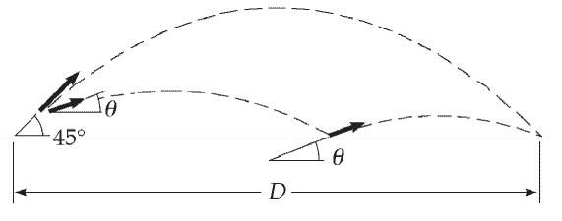  
  
ANS. Fig. P4.46**

For the bouncing ball,



where *θ* is the angle it makes with the ground when thrown and when bouncing.

(a) We require:



(b) The time for any symmetric parabolic flight is given by



If t = 0 is the time the ball is thrown, then  is the time at landing. So for the ball thrown at 45.0°:



For the bouncing ball,



The ratio of this time to that for no bounce is



**P4.47** Think of shaking down the mercury in an old fever thermometer. Swing your hand through a circular arc, quickly reversing direction at the bottom end. Suppose your hand moves through one-quarter of a circle of radius 60 cm in 0.1 s. Its speed is



and its centripetal acceleration is 

The tangential acceleration of stopping and reversing the motion will make the total acceleration somewhat larger, but will not affect its order of magnitude.

**\*P4.48 Conceptualize** You may have been on this ride and may be familiar with the situation. Initially, the cannon fires horizontally, and the cannonball immediately begins moving downward closer to the water. The minimum speed required for the cannonball will be determined by imagining that it hits the ship just as it falls to the level of the water. This is actually a good place to hit the ship, as a hole in the hull at the waterline will help flood the ship and sink it. In your later musings, because the cannonball is fired at an angle, it will follow a parabolic path toward the ship, moving upward at first, reaching a highest point, and then coming down.

**Categorize** We recognize a classic projectile problem, in which we use the *particle under constant acceleration* model for the vertical motion of the cannonball and the *particle under constant velocity* model for its horizontal motion.

**Analyze** (a) We choose the position equation from the particle under constant velocity model to describe the horizontal position of the cannonball fired horizontally:

 (1)

where we have assumed the initial position of the cannonball as *xi* = 0, and we have solved for the initial velocity in the horizontal direction.

The vertical position of the cannonball can be described from the particle under constant acceleration model:

 (2)

where we have chosen the origin as the point at which the cannonball leaves the cannon, and have recognized the initial vertical velocity component to be zero because the cannonball is fired horizontally. The time at which the cannonball is at a particular vertical position can be found from this equation:

 (3)

Substitute this time into Equation (1):

 (4)

Equation (4) tells us the required initial horizontal speed for the cannonball to reach a particular point described by the coordinates (*xf*, *yf*). Substitute numerical values to find the speed under the assumption that the cannonball just reaches the ship as it strikes the water:



(b) Now, what about the cannonballs fired at a lower speed due to the sludge in the barrel? The maximum range of the cannonball occurs when it is fired at 45°. Using Equation 4.13, this gives us

 (5)

Evaluate Equation (5) for the situation in which the cannonball is fired with 50.0% of the speed found earlier:



Because this distance is greater than the 75.0 m distance to the ship, the cannonballs can be fired at an angle to reach the ship. If this result had come out to be less than 75.0 m, the cannonballs could not reach the ship when fired at any angle.

**Finalize** The cannonballs fired at 45° might fly over the ship, missing it! In addition, you would like the cannonballs to reach the ship and sink the enemy in as short a time as possible, so it would be worthwhile calculating the angle at which you should fire the cannonballs at the reduced speed so that they arrive at the ship at the waterline, as did the cannonballs fired horizontally from the fresh cannon. What is that angle?

Challenge Problems

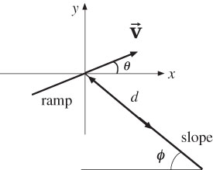**P4.49** ANS. FIG. P4.49 indicates that a line extending along the slope will past through the end of the ramp, so we may take the position of the skier as she leaves the ramp to be the origin of our coordinate system.

(a) Measured from the end of the ramp, the skier lands a distance d down the slope at time t:

**ANS. FIG. P4.49**



and



Solving,  and *t* = 2.88 s.

(b) Since ax = 0,



(c) 

**P4.50** (a) The horizontal distance traveled by the projectile is given by

:Art:Chapter 03 art:P03_44.eps ****

We substitute this into the equation   
for the displacement in *y*:

**ANS. FIG. P4.50**

Now setting  and , we have



Solving for *d* yields



or 

(b) Setting  leads to

 and 

**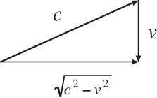P4.51** (a) For Chris, his speed downstream is *c* + *v*, while his speed upstream is *c* – v.

Therefore, the total time for Chris is



**ANS. Fig. P4.51**

(b) Sarah must swim somewhat upstream to counteract the effect from the current. As is shown in the diagram, the magnitude of her cross-stream velocity is .

Thus, the total time for Sarah is



(c) 

**P4.52** We follow the steps outlined in Example 4.5, eliminating  to find



Clearing the fractions gives



To maximize d as a function of *θ*, we differentiate through with respect to *θ* and set 



We use the trigonometric identities from Appendix B4:



to find



Next,  and  give cot 2*θ* = tan *φ* so

 and 

**P4.53** For the smallest impact angle

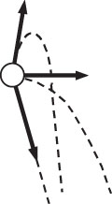 

we want to minimize vyf and maximize vxf = vxi.   
The final y component of velocity is related to   
vyi by  so we want to minimize vyi   
and maximize vxi. Both are accomplished by   
making the initial velocity horizontal. Then vxi = v, vyi = 0, and  At last, the impact angle is

**ANS. Fig. P4.53**



|  |
| --- |
| **ANSWERS TO QUICK-QUIZZES** |

1. (a)

2. (i) (b) (ii) (a)

3. 15°, 30°, 45°, 60°, 75°

4. (i) (d) (ii) (b)

5. (i) (b) (ii) (d)

|  |
| --- |
| **ANSWERS TO EVEN-NUMBERED PROBLEMS** |

P4.2 (a) ; (b);   
(c)   (d) a circle of radius 5.00 m centered at (0, 4.00 m)

P4.4 (a) ; (b) ;   
(c) 1.85 × 107 m/s; (d) 2.73°

P4.6 (a) , (b) The direction of the mug’s velocity is tan−1(2h/d) below the horizontal.

P4.8 53.1°

P4.10 (a) 76.0°, (b) Rmax = 2.13R, (c) the same on every planet

P4.12 (a) 0.852 s; (b) 3.29 m/s; (c) 4.03 m/s; (d) 50.8°; (e) t = 1.12 s

P4.14 (a) 28.2 m/s; (b) 4.07 s; (c) the required initial velocity will increase, the total time of flight will increase

P4.16 (a) *t* = *v*i sin*θ*/*g*; (b)

P4.18 0.033 7 m/s2 directed toward the center of Earth

P4.20 (a) 6.00 rev/s; (b) 1.52 × 103 m/s2; (c) 1.28 × 103 m/s2

P4.22 10.5 m/s, 219 m/s2 inward

P4.24 (a) See ANS. FIG. P4.42; (b) 29.7 m/s2; (c) 6.67 m/s tangent to the circle

P4.26 153 km/h at 11.3° north of west

P4.28 (a) 57.7 km/h at 60.0° west of vertical; (b) 28.9 km/h downward

P4.30 (a) 2.02 × 103 s; (b) 1.67 × 103 s; (c) Swimming with the current does not compensate for the time lost swimming against the current.

P4.32 27.7° E of N

P4.34 54.4 m/s2

P4.36 (a) ; (b) 

P4.38 (a) ; (b) ; (c) ;  
(d) 

P4.40 2*vit cosθi*

P4.42 (a) 25.0 m/s2; (b) 9.80 m/s2; (c) See ANS. FIG. P4.42; (d) 26.8 m/s2, 21.4°

P4.44 (a) See table in P4.44 (a); (b) From the table, it looks like the magnitude of r is largest at a bit less than 6 s; (c) 138 m; (d) We can require , which results in the solution.

P4.46 (a); (b) 0.949

P4.48 (a) *vxi* = 62.7 m/s (b) Yes, it is possible

P4.50 (a) See P4.50a for derivation; (b) 

P4.52 See P4.52for complete derivation.